The Purification of Mitotic Phosphatase Protein Cdc14p

Undergraduate Capstone Research Report

By

Emily Torres

Submitted to the Chemistry Faculty at

Emporia State University

In Partial fulfillment of The Capstone Research requirements

May 7, 2010

Two methods were employed to achieve soluble expression of Cdc14p. The first being the retrieval of CDC14 from a pET28 expression plasmid and insertion into a GST plasmid by use of the restriction enzyme NdeI. Before this could occur, alteration of an internal NdeI recognition sequence was attempted via site-directed mutagenesis. The second method being a process of exposing cells containing pET28 to a solution 10% sarkosyl or of 2% sarkosyl 2% triton X-100 and 20 mM CHAPS to disrupt any possible inclusion bodies of properly folded Cdc14p. Once soluble protein is extracted by either method, two assays will be preformed to ensure enzymatic activity and specificity will be examined.

Introduction
The cell division cycle protein, Cdc14p is a phosphatase found in Saccharomyces cerevisiae or budding yeast. It is a member of the tyrosine-phosphatase superfamily. Members of this family contain the highly conserved amino acid sequence, HCXAGXXR(S/T), in their active site. In this sequence, it is cystine²⁸³ that largely contributes to phosphatase activity.¹
Throughout mitosis, Cdc14p is contained in the nucleolus. During late anaphase, it is activated by Cdc5 and released.¹
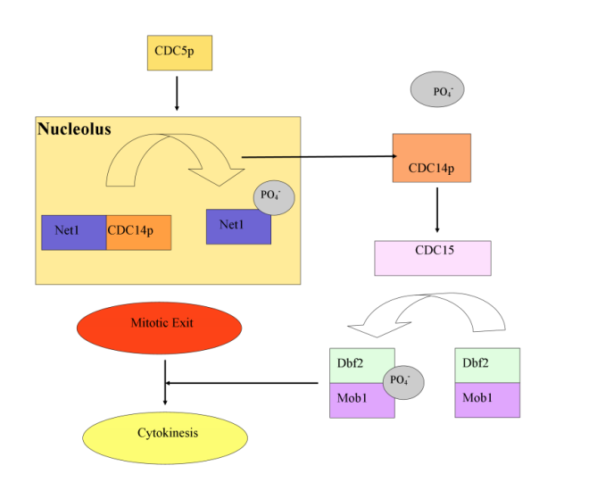
During mitosis, Clb-kinases are active, helping the cell to progress through the cycle. However, during the G1 phase, these proteins are inactive. It was found that Cdc14p also activates the Anaphase Promoting Complex (APC). This 11 subunit protein then goes on to degrade these Clb-kinases. Therefore, the end result of Cdc14p activation is cytokenesis and the cell coming into the G1 phase.³
FIGURE1. Cell signal cascade that occurs upon activation of Cdc14p by Cdc5 during late anaphase.

Importance
Through the creation of cDNA libraries, two human homologues, hCdc14A and hCdc14B have been discovered.² In previous studies, researchers were able create mutant yeast cells deficient in Cdc14p activity. These cells would progress normally through the cell cycle, but would stop and die at late anaphase. Rescue of these cells was possible by addition of human Cdc14A. It was also found that both of these homologues activate the APC.⁴
Recent research has also begun involving Cdc14 in human cancer cells. Depending on the type of cancer, one of two events has been observed: either the levels of Cdc14 are abnormally high or low or the gene encoding for Cdc14 is mutated.^{2,4} Mutations in the DNA would affect the function of the produced protein. If human and yeast Cdc14 are similar in both sequence and function, than any research into Cdc14p and its enzymatic activity could be beneficial to human cancer research.

Previous Research
Previous to our work, CDC14 was successfully cloned into a pET28 expression plasmid. This plasmid contains a histadine tag to assist in protein folding and purification techniques. Expression of Cdc14p was achieved, but the extracted protein was found to be insoluble. When expression of a desired gene is occurring at such a high rate, sometimes the protein does not fold properly. Proper folding is crucial to enzymatic activity; therefore this extracted protein could not be studied.

Research Design
Two methods were used to receive soluble expression of Cdc14p. The first involved the retrieval of CDC14 from the pET28 plasmid and then insertion into a GST plasmid. This plasmid contains a different tag that also assists in protein folding. In order to receive complete expression of Cdc14p, the entire coding region needed to be removed from pET28. Restriction enzymes are used in for this process; NdeI was chosen. Upon selection, we examined the sequence of CDC14 and found an internal NdeI recognition sequence. Any attempts to remove our gene would therefore be reduced by half.
Site-directed mutagenesis was selected as a way to alter this internal site. Site-directed mutagenesis is achieved through the polymerase chain reaction (PCR), so primers needed to be designed. During PCR, primers will bind to the denatured pET28. Therefore, forward and reverse primers were designed. They were designed to be complementary to the desired area of our gene, so that they would bind specifically and to also be complementary to each other. This is so both stands of the plasmid would be synthesized. Our primers also need to contain a desired mutation. The internal NdeI site relative to the reading frame of our gene is:

XCA|TAT|GXX

The middle codon shown is for tyrosine. Our primers will be complementary to the region of our gene that contains this internal site. However, they will contain a one base pair change so that the nucleotide located in the third position or the wobble position, will be changed from a thymine to a cytosine. With this change, NdeI will no longer recognize this region, but the resulting mRNA will still encode for a tyrosine at this location.
Our primers, with this mutation, will bind to the denatured plasmid. DNA polymerase will then synthesize both strands and upon reaction cooling, complementary strands will associate back together. With a final ligation reaction, the plasmid will be sealed and we will again have a circular, functional double stranded plasmid. Once this process is complete, we will be able to successfully retrieve CDC14 and insert it into the new plasmid. If soluble expression is received, the resulting extracted protein can be purified and studied.
The second method employed will involve using the pET28 plasmid without alterations. It will simply be transformed into competent E. coli. These transformed cells will then be grown up into large cultures and introduced to a solution containing sarkosyl, triton X-100 and CHAPS or a solution of just sarkosyl. When a protein is being made from an expression plasmid, such a high quantity is being made that certain events can take place inside the cell. One of which is the possible aggregation of properly folded protein into tightly associated inclusion bodies. When the cell is then lysed, these inclusion bodies cannot be properly released and only the insoluble, incorrectly folded protein is extracted. These three compounds work as mild detergents to synergistically break up inclusion bodies. Upon lysis, the properly folded protein can then be released and extracted.

Experimental
Site-Directed Mutagenesis – 1
Four experimental PCR samples were made with the following reagents:
- Designed primers
- pET28- for each reaction a different sample of plasmid was used; 7-16A, 7-16C, 10-7A, and 10-7C
- From a Phusion© HotStart PCR kit: 5X buffer, nucleotides, HotStart polymerase
The kit used also provided a control primer mix and plasmid for a separate positive control reaction, making a total of five PCR samples. Reactions were set up in the following order:
- H₂O – to bring the total reaction volume to 50µL
- 5X Phusion© buffer
- Nucleotides
- Primers
- Template DNA
At this point, all samples were thoroughly mixed. Once the thermocycler had been programmed by Dr. Kim Simons the Phusion© polymerase was added, reactions were placed in the apparatus and allowed to run. Upon reaction completion, the restriction enzyme DpnI was added to degrade the original pET28. The newly amplified plasmid was left intact.
Verification of amplification was done via gel electrophoresis. All PCR samples were purified using the QIAGEN Nucleotide Removal kit. Each sample was placed into a provided spin column and ten volumes of PN binding buffer was added to one volume of reaction sample. Solution was centrifuged, flow though discarded. PE wash buffer was added to the column and the solution was centrifuged again, flow though discarded. Column was spun again to ensure dryness. Tris EDTA buffer was added to the column, samples were allowed to sit before they were again centrifuged. Flow through from the spin column was labeled and stored.
At a later time, all samples were separated via gel electrophoresis by Dr. Kim Simons

Site-Directed Mutagenesis –2
PCR was set up and run identical to round 1; however, the annealing temperature was lowered by Dr. Kim Simons.
Verification was done by transforming each PCR sample into competent E. coli. Previous to verification a ligation reaction was done by Dr. Kim Simons. Cells were removed from the freezer and aliquoted into five tubes; one for each sample. 1 µL from each PCR sample was added; samples were allowed to sit on ice for 10 minutes. Each solution was then heat shocked for 30 seconds at 42ºC. After heat treatment, liquid Luria-Bertani (LB) media was added to all samples and they were allowed to incubate for 30 minutes at 37ºC, with agitation. Experimental samples were plated on media containing kanamycin, control on media containing ampicillin.

Site-Directed Mutagenesis- 3
All procedures for this round were done identical to the second. However, shorter primers were designed and used.

Triple Detergent Method
For this second method, the original pET28 plasmid was transformed into BL21-codonplus-DE3-RIPL E. coli cells. The plasmid samples used were 7-16A and 10-7C. A negative control reaction (cells with no DNA added) was set up as well. The same transformation procedure used for the PCR product was used for this method, kanamycin plates again used.
From colonies produced on the 7-16A and 10-7C plates starter cultures we made by Dr. Kim Simons. Two liquid starter cultures were made from each plate. From the starter cultures larger cultures were made, resulting in four large cultures of transformed cells; 7-16A(1), 7-16A(2), 10-7C(1) and 10-7C(2). For both the starter and larger cultures, LB media was used.
Once the larger cultures had been allowed to incubate, a sample from culture 7-16A(1) was read at 600 nm. Its OD was found to be 0.135. LB media was used as a blank. To all four cultures IPTG was added, samples were taken before and after induction for SDS-PAGE analysis. Cells incubated at 27ºC, were removed and centrifuged by Dr. Kim Simons. Cell pellets were stored in the freezer.
Frozen cell pellet from culture 7-16A(1) was resuspended in 0.1M Tris and 0.5M NaCl. Cells were then lysed via sonicfication at 13 Watts for 30 seconds, three times. Two minute breaks were taken between each. After sonification, a sample was taken for SDS-PAGE. Resulting cell lysate was then divided into two samples. Both were centrifuged to remove cellular debris, and a sample was again taken.
To the first, a solution of 10% sarkosyl was added. To the second a solution of 2% sarkosyl 2% triton X-100 and 20 mM CHAPS. Both solutions also contained 50mM Tris 250mM NaCl. Both pellets were broken up after addition of the solutions and were again sonicated the same as before. After centrifugation, samples were taken from both.
Supernatant from the first centrifugation, pellets and supernatant from the final centrifugation were saved. All samples were run via SDS-PAGE.

Results
Site-Directed Mutagenesis – 1
The size of pET28 is known, in the produced gel a large band should have been seen at the proper location. A large band corresponds to amplification. Such a band was only seen for the control reaction.

Site-Directed Mutagenesis –2
Both the pET28 plasmid and the control plasmid contain resistance genes for the corresponding antibiotic present in the media. Therefore, cells could only grow on this media if they received a plasmid during transformation. Only the control reaction produced growth. The same results were seen in the third attempt.

Triple Detergent Method
From FIGURE 2 it can be seen that there was slight production of our protein before induction with IPTG, this is observed as faint bands in lanes 3-6. Also, the 10-7C samples produced more intense bands than the 7-16 samples. However, more intense bands can be seen after induction. The most intense band can be seen from the sample taken from the 7-16A culture. This suggests that this culture produced more Cdc14p than the 10-7C culture, after induction. All bands correspond to the location appropriate for Cdc14p relative to the protein markers, 62 kD.¹
After induction, the cells were lysed and exposed to one of the two solutions; results seen in FIGURE 3. In lane 1, an intense band can be seen. This sample comes from the total cell lysate. From the sample taken after centrifugation a band can also be seen, although it is not as intense as lane 1. When comparing lanes 4 and 5, a more intense band can be seen from the sample taken from the cells that were exposed to the 10% solution. It was also noted that after the final centrifugation, the pellet formed from the sampled containing only 10% sarkosyl was much more solubilzed.
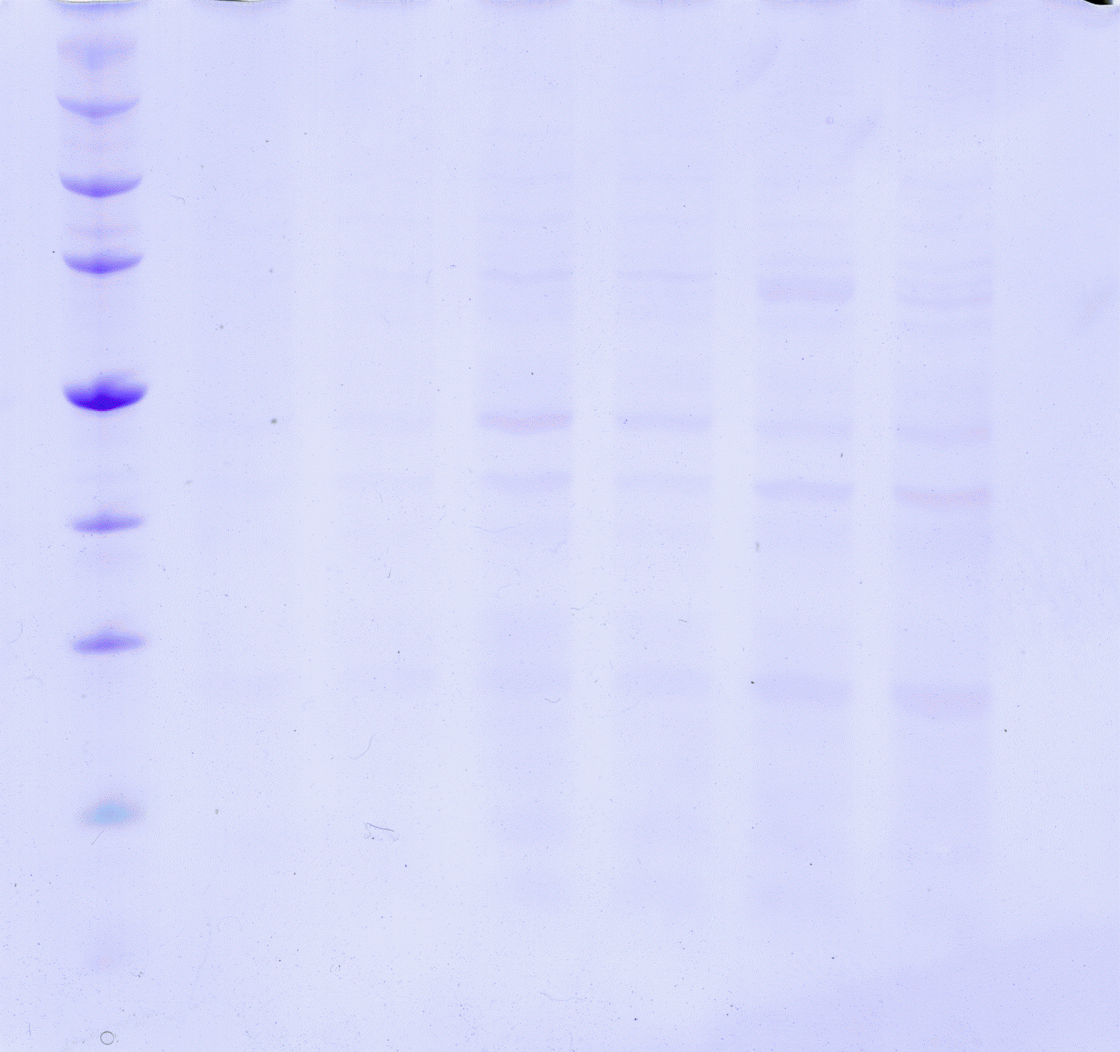
FIGURE 2. Gel from samples taken before and after induction with IPTG. Lane 1- protein markers, lane 2- skipped, lane 3- 7-16A(1), lane 4- 7-16A(2), lane 5- 10-7C(1), lane 6- 10-7C(2), lane 7- 7-16A after induction, lane 8- 10-7C after induction. Relative size of Cdc14p is marked.
Discussion
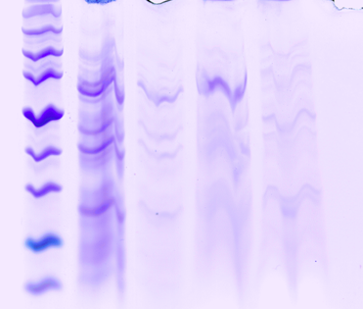
After the first round of PCR was found to be unsuccessful, a lower annealing temperature was used to help with primer binding. During PCR, the annealing cycle is when the primers bind to the denatured template DNA. The temperature at which this cycle occurs is dictated by the length of the primers, or by their corresponding melting temperature. The temperature must be high enough so that the primers bind specifically, but if it is too high the primers will not bind at all. If there is no binding, then there is absolutely no amplification. That is what we saw after the first round of PCR. Since, the control reaction produced amplification, obviously the annealing temperature was appropriate for the control primers.
FIGURE 3. Gel from samples taken throughout the triple detergent process. Lane 1- protein markers, lane 2- after sonification (total cell lysate), lane 3- after centrifugation to remove cellular debris, lane 4- cells introduced to the 10% sarkosyl solution, after final sonification and centrifugation, lane 5- cells introduced to triple detergent solution, also after final sonification and centrifugation.
For the final PCR attempt shorter primers were used to also help with binding. Sometimes after unsuccessful PCR, simply shortening the primers can produce amplification. It is thought that perhaps when primers reach a certain length they begin to form secondary structure. If this occurs, they of course cannot bind to the template DNA and no amplification occurs.
In both PCR trails 2 and 3, verification of amplification was done via transformation; with selection of transformants by antibiotic resistance. The only way a cell could grow on the media was if it received plasmid with the corresponding antibiotic resistance gene. Complete lack of growth means that there was no amplification and no plasmid to be transformed into the cells in the first place. This is what was seen for all experimental samples. For all three attempts, PCR was unsuccessful.
From the results seen in FIGURE 2, it could be said that the pET28 plasmid from the 7-16A sample had better expression of Cdc14p. Any difference between the 7-16 and 10-7 plasmid samples is not known. They were prepared previously by Dr. Kim Simons when he was able to clone CDC14 into pET28. From this figure it can be observed that addition of IPTG induced expression of Cdc14p. However, all four samples taken before induction produced visible bands at the location where Cdc14p is expected to be. The 10-7C samples having more intense bands; this could correspond to “leaky” expression from the operon contained in the 10-7C pET28 plasmid.
Culture 7-16A(1) was chosen to be centrifuged; the cells resuspended, lysed and then exposed to one of the two detergent solutions. Results can be seen in FIGURE 3. There are many protein bands in the lane corresponding to the cellular lysate, lane 2. This means that lysis was achieved. Also an intense band is seen at location relative to the size of Cdc14p. We did not expect to see this same band in lane 3. At this point the supernatant contains soluble proteins; previous expression of Cdc14p produced insoluble protein. A different host stain of E. coli was used for transformation in our procedures than was in the previous research. Perhaps some unknown differing component between cells types is affecting protein folding.
Our second unexpected result is the band seen in lane 4. The band is more intense than the corresponding one in lane 5. Research stated that a higher quantity of soluble proteins could be extracted from cells that were exposed to the triple detergent solution than those exposed to just the 10% sarkosyl solution. Our results are opposite of this.

Conclusion
Upon receiving soluble expression of Cdc14p, we will next test for activity. Soluble expression corresponds to proper protein folding, however, extracted soluble proteins can still in inactive. The first assay used will be the phosphatase assay. Cdc14p will be incubated with para-nitro-phosphate, a naturally colorless compound. If Cdc14p is able to remove the phosphate group, producing para-nitro-phenol, a yellow color change will be seen. To ensure that our extracted protein can work on peptides and not just small compounds, a second assay will be done. This involves the incubation of Cdc14p with small peptides that have had phosphate groups attached.
Once enzymatic activity is verified, the specificity of Cdc14p will be examined. In vitro, kinases have been observed to be very specific. The same cannot be said for phosphatases, which dephosphorylate a wide variety of targets in vitro. It is thought that there is something in the cell that is guiding Cdc14p. In vitro, tests will be done on only Cdc14p and Cdc14p in the presence of Cdc5; the kinase that activates it. Resulting specificity will be observed.
Any gained knowledge of Cdc14p could be applied to other homologous, including the previously mentioned hCdc14A and hCdc14B. Investigating the specificity of Cdc14p and what affects it could have implications in human cancer research. Cancer cells stem from normal cells that begin to divide incorrectly. It has been observed that either Cdc14p levels or the gene are changed in cancer cells, along with many other cell components. Perhaps, a change to this cell division cycle protein is what causes the normal cells to begin to divide incorrectly. Our research is attempting to discover this change.

REFERENCES
1. Taylor, G. S., Liu, Y., Baskerville, C. and Charbonneau ( 1997) The Activity of Cdc14p, an Oligomeric Dual Specificity protein Phosphatase from Saccharomyces cervisiae, is Required for Cell Cycle Progression. The Journal of Biological Chemistry, Vol 272, No. 38, 24054-24063
2. Li, L., Ernsting, B R., Wishart, M. J., Lohse, D. L. and Dixon, J. E. (1997) A family of Putative Tumor Suppressors Is Structurally and Functionally Conserved in Humans and Yeast. The Journal of Biological Chemistry, Vol 272, No. 47, 29403-29406
3. Visintin, R., Craig, K., Hwang, E. S., Prinz, S., Tyers, M. and Amon, A. (1998) The Phosphatase Cdc14 Triggers Mitotic Exit by Reversal of CDK-Dependent Phosphorylation. Molecular Cell, Vol. 2, 709-718
4. Paulsen, M. T., Starks, A. M., Derheimer, F. A., Hanasoge, S., Li, L., Dixon, J. E., and Ljungman, M. (2006) The p53-targeting human phosphatase hCdc14A interacts with the CdkI/cyclin B complex and is differently expressed in human cancers. Molecular Cancer, Vol. 5, No. 25

